FOR IMMEDIATE RELEASE
MEDIA CONTACT: Kait Fletcher
kfletcher@waterhousepr.com | (423) 424-3077
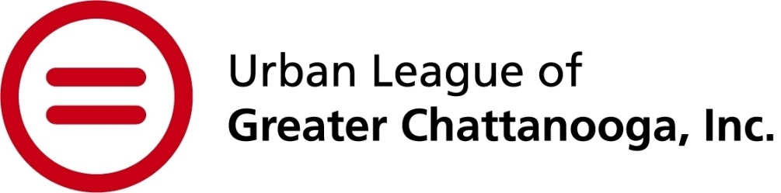
Urban League hosts 41st annual Equal Opportunity Day on Dec. 7
CHATTANOOGA, Tenn. (Nov. 14, 2023) – The Urban League of Greater Chattanooga (ULGC) will host its 41st annual Equal Opportunity Day (EOD) breakfast on Thursday, Dec. 7 from 8-9:45 a.m. at the Chattanooga Convention Center. BlueCross BlueShield of Tennessee will serve as this year’s presenting sponsor.
Acting as ULGC’s primary fundraiser, EOD brings hundreds of business and community leaders, elected officials and program beneficiaries together to celebrate and support the Urban League movement. It also provides a deeper perspective for those not as familiar with the organization and its movement. Funds raised during the event will go towards supporting the operation of ULGC’s three empowerment centers, assisting diverse community members in all stages of life.
“We are fortunate to have so many supporters who have begun to understand what I mean when I say, the Urban League movement,” said Candy Johnson, ULGC president and CEO. “We are more than an advocacy-focused organization. We provide direct services to individuals from various walks of life through the lens of equity and accessibility.”
During the event, special recognitions will be awarded to those who embody the spirit of the Urban League movement. There will also be an opening performance, dialogue from program participants about the Urban League’s impact and acknowledgment of the Urban League’s recent Inclusion by Design cohort.
“We’re proud of the work of ULGC and its commitment to help create a more inclusive Chattanooga. Each year, EOD allows all of us the opportunity to celebrate our successes and continue the necessary work to empower communities and change lives,” said Dalya Qualls White, chief communications officer for BlueCross BlueShield of Tennessee and ULGC board chair.
Table sponsorships are available until Nov. 16. Both table sponsorships and individual tickets can be purchased at https://shorturl.at/fi258. For more information about the event or how to support ULGC, visit www.ulchatt.net or email info@ulchatt.net.
About Urban League of Greater Chattanooga
The Urban League of Greater Chattanooga is an affiliate of the National Urban League, the nation's oldest and largest community-based movement devoted to empowering African Americans and other underserved individuals to enter the economic and social mainstream. Since 1982, the Chattanooga affiliate has served many thousands of economically disadvantaged persons, individuals representing communities of color, and minority-owned businesses through programs and initiatives that promote educational attainment, economic development, self-sufficiency, and inclusive leadership opportunities.
###

