PHOTO RELEASE
MEDIA CONTACT: Kait Fletcher
kfletcher@waterhousepr.com | (423) 424-3077
Urban League presents leadership awards at Equal Opportunity Day
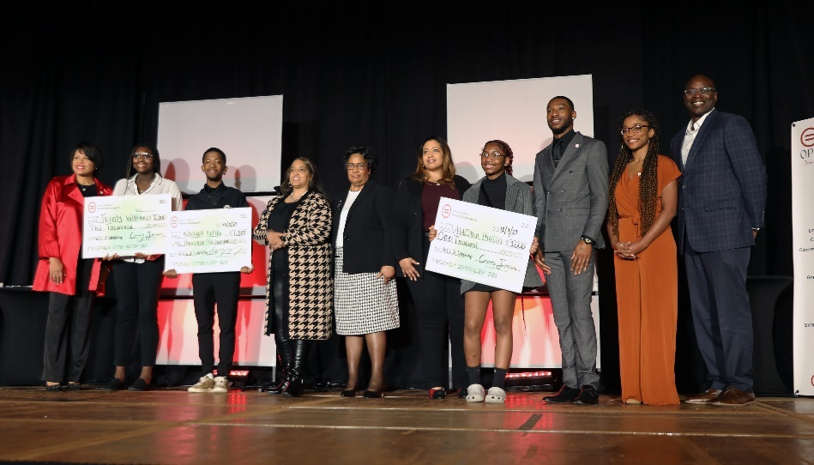
CHATTANOOGA, Tenn. (Dec. 7, 2023) – The Urban League of Greater Chattanooga (ULGC) held its 41st annual Equal Opportunity Day this morning at the Chattanooga Convention Center. This event acts as a celebration of the Urban League Movement and is the primary fundraiser for the organization. ULGC also presented numerous leadership and advocacy awards to members of the community and local organizations.
The award recipients include the following:
- Inclusion by Design Award: City of Chattanooga
Recognizes an organization that embraces inclusion through its business practices and community engagement activities.
- Community Impact Award: The University of Tennessee at Chattanooga
Celebrates an organization or individual who has demonstrated a sustainable impact that elevates the community’s standard of living and contributes to the overall quality of life.
- Whitney M. Young, Jr. Award: Valoria Armstrong
Recognizes outstanding service by an individual or organization for demonstrated leadership and commitment to the cause of justice, social consciousness and civic involvement.
- Warren E. Logan Scholarship Awards: Chazmin Hinton, Wendell Patillo and Trinity Williams
- Spirit of the Movement Award: Urban League of Greater Chattanooga Young Professionals Auxiliary
- Board Emeritus: Judge Curtis Collier and Dorothy Grisham
For outstanding support and service to the Urban League of Greater Chattanooga.
ULGC also honored the recent graduates of its Inclusion by Design program. This is the seventh cohort to complete the executive-level training program.
The graduates included the following:
- Alisha Moore, BlueCross BlueSheild of Tennessee
- Althea Jones, Tennessee Valley Authority
- Christina Gindi, U.S. Express
- Courtney Cochran, BlueCross BlueSheild of Tennessee
- Diego Trujillo, Hamilton County Schools
- Jeremy Mason, Pinnacle
- Larvizo Wright, Unum
- Martina Harris, Chattanooga State
- Melanie Cross, Tennessee Valley Authority
- Reggie Wilkerson, EPB
For more information about ULGC, visit www.ulchatt.net.
Thank you for reviewing and please let me know if you have any questions.

