FOR IMMEDIATE RELEASE
MEDIA CONTACT: Thalia Cruz
tcruz@waterhousepr.com | (423) 284-8051

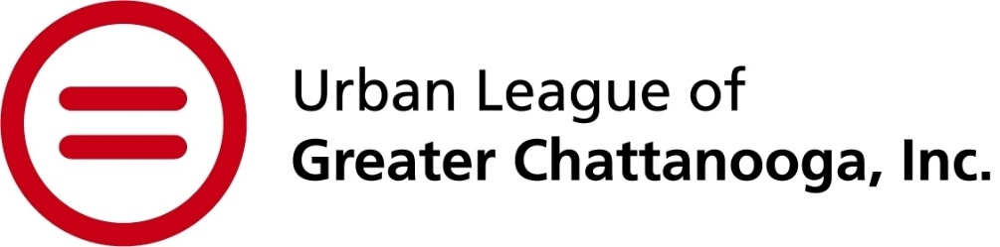

Urban League celebrates Black history all month long with youth advocacy, literacy, racial equity education and an open house

CHATTANOOGA, Tenn. (Feb. 14, 2024) – The Urban League of Greater Chattanooga (ULGC) launches special events for Black History Month beginning on Thursday with a viewing of the Right to Read documentary, followed by part two of the Youth Leadership Symposium on Feb. 19. Later in the month, the community is invited to the Black History Month Open House, and a Racial Equity Education two-day session will close out the month-long celebration.

“While we celebrate Black history and culture all year long at the Urban League, this month is set aside for intentional remembrance and celebration of our achievements, heritage, struggle and impacts on the shaping of the American economy and culture.” said Candy Johnson, president and CEO of ULGC. “Throughout our many events, we hope to engage and inspire a diverse range of community members and to encourage them to become more involved with our programming and movement to enable African Americans, other ethnic minorities and disadvantaged persons to secure economic self-reliance, parity, power and civil rights.”

SCHEDULE:
Feb. 15: Right to Read Documentary Viewing
5:30-7:30 p.m.
Urban League of Greater Chattanooga – 401 E. ML King Blvd. Suite 301
The Right to Read shares the stories of an NAACP activist, a teacher, and two American families who fight to provide our youngest generation with the most foundational indicator of life-long success: the ability to read.
To register, visit https://fundraise.givesmart.com/form/OnsmbA?vid=13th0a.

Feb. 19: Youth Leadership Symposium Part II
11:30 a.m. to 2:30 p.m.
Bessie Smith Cultural Center (content geared towards students ages 12 and up)
The Youth Leadership Symposium builds on last month’s virtual session and brings students together to expand on civic engagement and advocacy concepts. This year’s event theme is “The King’s Philosophy: Shifting the Cultural Climate Around Civic Engagement.” Each year the Urban League’s Project Ready program students help to coordinate and lead this event with content and activities designed to educate, empower and engage middle and high school aged students around Dr. King’s philosophy. Event activities explore historical and current advocacy concepts through a variety of group, hands-on and entertaining activities including a student-led discussion. This event is free due to the generous support of sponsors, Benwood, FootPrint Foundation and the Enterprise Mobility Foundation, but requires registration as space is limited. To register, visit http://igfn.us/form/g31oHw.

Feb. 27: Black History Month Open House
5-7 p.m.
Urban League of Greater Chattanooga
Meet the team, network with other community members and learn more about ULGC and our impact in the community!

Feb. 28-29: Racial Equity Education 2-Day Session
9 a.m.-5 p.m.
Urban League of Greater Chattanooga
The Racial Equity Institute’s (REI) two-day Phase I training is designed to develop the capacity of participants to understand racism in its institutional and structural forms. Moving the focus from individual bigotry and bias, the REI Phase I workshop presents a historical, cultural, structural and institutional analysis of racism. With a clear understanding of how institutions, systems, and culture are producing unjust and inequitable outcomes, participants are better equipped to work for change. Phase I builds the capacity of participants to identify the root causes of disparity and establish goals and strategies based on that deeper understanding. Participants develop an analysis of institutional racism that helps their organization develop a common understanding of the problem and a common language to address it. This paradigm shifting experience redefines issues of equity as they manifest in systems and institutions today and the attendant actions of individuals who seek to address them. To register, visit https://fundraise.givesmart.com/form/SJ8jLQ?vid=13tgzy. (Participants are required to attend both days – seats limited to the first 40 registered)

For more information about ULGC, visit www.ulchatt.net or call 423-756-1762.

About Urban League of Greater Chattanooga
The Urban League of Greater Chattanooga is an affiliate of the National Urban League, the nation's oldest and largest community-based movement devoted to empowering African Americans and other underserved individuals to enter the economic and social mainstream. Since 1982, the Chattanooga affiliate has served many thousands of economically disadvantaged persons, individuals representing communities of color, and minority-owned businesses through programs and initiatives that promote educational attainment, economic development, self-sufficiency, and inclusive leadership opportunities.
###

